CompeGPS Team launches TwoNav Aventura for Outdoor activities

The new navigator includes revolutionary characteristics for this sector: An incredible autonomy of more than 20 hours, the possibility to navigate inside the city and in the mountains though the concept of “Dual” navigation and a compatibility with almost all the formats and brands.


Barcelona, June 1st 2009. The Spanish company CompeGPS Team launches on the market TwoNav Aventura, the new navigator for all the Outdoor World’s fans and professionals. The proprieties inserted in this new GPS represent a clearly evolution in the European navigators sector. TwoNav Aventura improves the quality of the Outdoor sports practice, thanks to its shock resistance, a capacity of facing all climatic conditions, a compatibility with numerous maps from all around the World even if it is from other brands, and an extraordinary autonomy of its battery combined with the possibility of adding AA piles to go even further.
Through its concept “Aventura without limit”, the brand wishes to give his clients the opportunity to go wherever they want, converting the GPS into a really helpful device, clearing out the possible usual limitations. With TwoNav Aventura, it is now possible to enjoy every Outdoor activities from the beginning to the end though all its functions: from a quiet preparation of your trip at home, the On-road navigation to the spot, the following of the whole adventure and the posterior study of your activity with a bunch of useful data and graphics.
According to Pascal Darré, CompeGPS Marketing Manager, “the TwoNav Aventura launch was received with great expectation in the Outdoor world, as it comes from the latent market need to create a GPS that gives more tools to professional and Outdoor sports amateurs.”

TwoNav Aventura characteristics
TwoNav Aventura presents an exclusive design which gives priority to the screen visualization and the use in during the most extreme conditions. Let’s discover some of the main characteristics bringing by this new device in the Outdoor World:
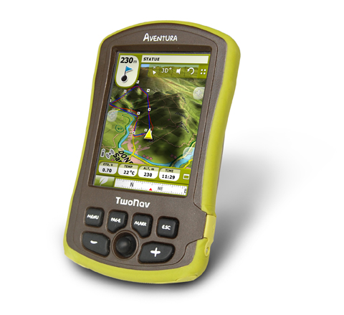
Large autonomy
Li-Ion 3.000 mA/h or 3 AA battery accessories
Duration of about 10-20 hours depending usage
3,5” Touchscreen
high definition color
Transflective screen
(Viewable under direct sunlight)

Ready for extreme Outdoor conditions

Compatible with numerous map providers
3D view
32GB SD memory card
Both On Road (turn by turn voice guidance) and Off Road navigation
Unlimited track, route and waypoint creation and management
Recommended price 599 €*

*The Spanish pack includes TwoNav Pocket version 2.0 with topographic and urban maps of whole Spain.
For all other countries, it comes with TwoNav Pocket version 2.0 and a maps offer (topographic or/and urban) which will depend of our catalogue. You can already check on our Web the different packs available (www.twonav.com).
Water resistant
Electronic compass Barometer, GPS SirfIII
Accessories: 4Gb SD card, device cradle, car bracket, 12V cigar power plug y cable USB PC



CompeGPS Team SL is a top company in outdoor cartographic and GPS navigation, developing applications for PC, PDA and mobile phone. The products are recognized as best in class by international press and customers from around the world thanks to a high quality, attractive prices, regular updates and improvements of its functions.

For more information, interviews or photography please contact:
Elena Compte
ecompte@creatimina.com
Tel: 934763927

