Press KIT

The main objective of CompeGPS is to help his customers to have nicer and easier Outdoor experiences, providing them the most powerful and professional navigation softwares and now hardware.

ABOUT COMPEGPS
CompeGPS Team SL is a top company in outdoor cartographic and GPS navigation, developing applications for PC, PDA and mobile phone. The company impresses for its dramatic evolution since 2001, and with now more than twenty employees, offers its products all around the World and plans to double its turnover during 2009. CompeGPS Outdoor products are recognized as best in class by international press and customers from around the world
OUTDOOR ACTIVITIES
The softwares created by CompeGPS can be used by a lot of different Outdoor activities:
- By Foot: hiking, backpacking, fishing, hunting
- Mountain Bike
- Air: parachuting, hang gliding, balloon
- Motor: 4x4, quads, Motorbikes

DISTRIBUTION
CompeGPS Team SL products can be bought directly in our two websites www.compegps.com, www.twonav.com or though our distributors channel.


COMPEGPS PRODUCTS
TwoNav Aventura is a new generation of navigators for all Outdoor lovers. Some of the various exclusive characteristics are the following:

 | Ready for extreme outdoor conditions  Very tough and resistant components  Don't worry about rain or humidity  A large range of accessories to always take it with you
 | Big and polyvalent screen  Big size to be aware of any detail, even under the sunlight (transflective)  Touch screen for an agile, efficient and intuitive use  Both "landscape" and "portrait" view for a total liberty
 | Lots of maps for you  Huge diversity of available maps  Use any kind of map without problem of compatibility  Take them all with you with a high capacity SD card reader (up to 32 GB)
 | Precision instruments  Keep always the right bearing with the electronic compass  Take the weather into account and improve altitude accuracy with Barometer & Thermometer  SirfIII GPS for the best accuracy and reliance
 | Real 3D Maps & Navigation  Very impressive 3D view to view your maps in real relief  Enjoy the most Spectacular and realistic views
 | Long Lasting Battery  Let time be your friend (a 20 hours battery)  Unbeatable autonomy to live all your experiences to the end (Li-ion battery + AA batteries)

A new concept: “Dual” navigation

The first GPS really conceived for both "Onroad" and "Offroad" Navigation

 | "Onroad" Navigation  - Turn by turn voice guidance  - Next manoeuvre indication  - Tele Atlas maps from around the world  - Speed limit alerts  - Several ways to choose destination address, map, historic, home, POI's...  - Favourites manager  - User-friendly interface
 | "Offroad" Navigation  - Unlimited track, route and waypoint creation and management  - Navigate to waypoint, following a track, route, etc.  - Altitude (graphs, elevation maps, current altitude, barometric altimeter...)  - Up to 3 maps simultaneously on screen  - Wide format compatibility  - Dozens of On-screen trip stats

MORE PRODUCTS

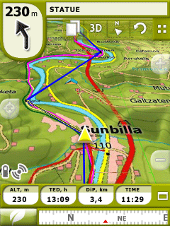
TwoNav Software version 2.0
Don't limit your mobility to just one kind of terrain. With TwoNav you can enjoy the best On-road and Off-road assistance, obtaining a complete solution to your orientation needs.
Use urban navigators' typical features (door-to-door navigation, next manoeuvre, etc.) beside the versatility of the CompeGPS Off-road tools (map viewing, movement stats, position reference edition, etc.). All in just one and unique software.
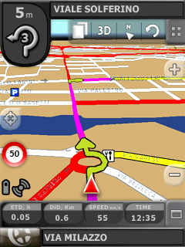
A user friendly interface will let you access a great diversity of functions so the software can be adapted to your needs in any situation. Wherever you are, TwoNav will help you find the best way to reach your destination efficiently and safety.
TwoNav gives you the flexibility to use the most appropriate cartography for your needs. Any kind of map (topographic, orthophotos, elevation maps, etc.) may be used to obtain complete information about any terrain.
TwoNav Tablet is the version of the program for PC(Windows XP/Vista), created to work on a laptop or Tablet PC/UMPC. TwoNav Pocket is the PDA version.

A wide catalogue of maps
CompeGPS offers among all its products a wide variety of maps in order to enjoy the navigation experience as well in the city or in during your Outdoor activities and in almost every place around the World. Urban maps, topographic maps, and 3D maps to always find what you really need.

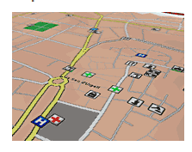
Urban maps
The best urban maps directly brought from the most prestigious cartography producers (Tele Atlas) and specially adapted for TwoNav software.
Get the most detailed information about any town, district, street or even pathways. Their gas stations, hotels, leisure centres, health services, etc. All recently updated to minimize the disarrangements that may appear from the unavoidable changes of the environment.
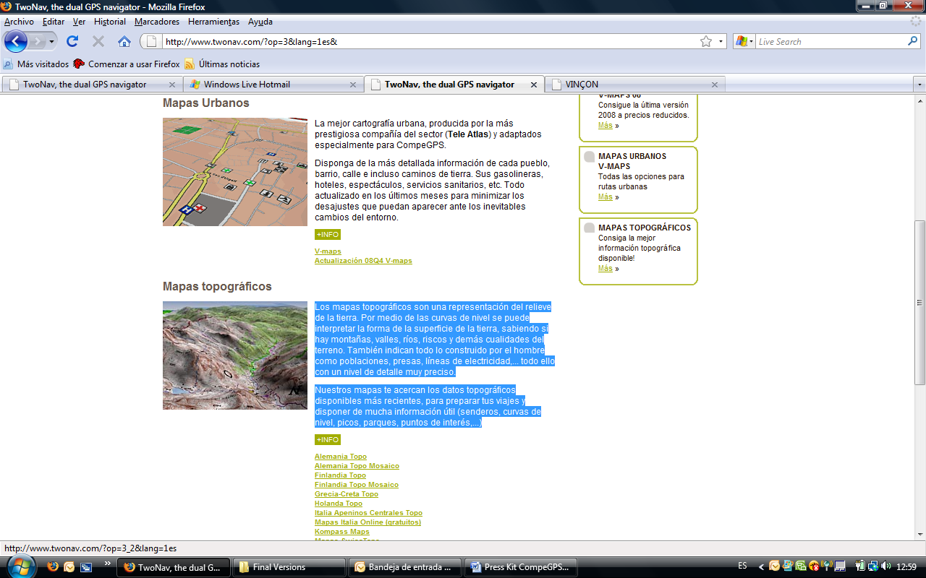

Topographic maps
Topographic maps are land maps that display relief using contour lines along with natural and man-made features, all with extensive close-up detail.
CompeGPS maps bring you the ultimate topographic data available, with perfect scale to make a detailed planning of your trips and loads of useful information (paths, contour lines, peaks, parks, towns, points of interest...)
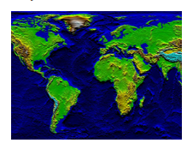
3D Maps
Use the 3D maps of CompeGPS to have the ground altitude data available for any zone of the world, including the sea bed. Explore the orthography of any zone you wish, set your maps on the corresponding landscape and provide all your works with the altitude data.

For more information, interview, photography, pictures, please contact:
Elena Compte
Tel.: 93.476.39.27
ecompte@creatimina.com

